North Country Spinners Membership Form - 2020
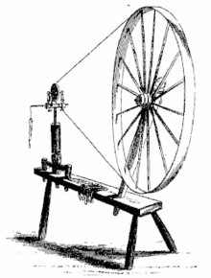
New _____ Renewal_____

Name:_____________________________________________________________
Address:___________________________________________________________
City:______________________ State:_______ Zip:_________ County:_________
Phone:_____________________ E-mail:_________________________________
PLEASE ALSO ENTER YOUR NAME AND E-MAIL AT THE BOTTOM OF THIS FORM.
Ravelry Name:______________________________________________________
Dues: $30.00 for single membership and $40.00 for a family
(Pro-rated dues for July through December: $15.00 for single membership and $20.00 for a family)

Please make checks payable to: North Country Spinners, Inc.
Please send checks to: Cynthia Manno, 178 Florence Place, South Plainfield, NJ 07080

The newsletter is sent via e-mail to members whose dues are current.
(A copy will be sent via USPS to those who do not have computer access).

Area(s) of fiber experience: _____ Spinning _____ Weaving

_____ Knitting _____ Crocheting _____ Other (please list: ________________________)

GET INVOLVED! We are active members, serving the guild and the community!

Guild Service: Officer or committee person; sharing a skill by teaching a program or workshop; meeting site preparation and clean-up; assisting with refreshments.
Community Service: Demonstrating or teaching at various events; making items for guild charities, booth preparation and clean-up at Garden State Sheep Breeders Festival and other events.

How will you participate as an active guild member?: (check all that apply)

____Serve as Officer or Committee Person ____Provide Refreshments ____Demonstrate/Teach a Skill at an event ____Share/Teach a Skill
____Meeting Site Preparation and Clean-up ____Event Site Preparation and Clean-up

Office Use: Date:______ Check #:_____ Cash:_____ Amt:_____ Card:_____ Tag:_____
______________________________________________________________________________
MUST complete to receive newsletter:
North Country Spinners Membership Form - 2020
New _____ Renewal_____
Name:_____________________________________________________________
E-Mail Address:_____________________________________________________

